Jousting Robot Senior Project
With Wireless Controller

Weekly Report 5

Ximing He
March 2, 2017

What I did last week
Optimize joystick performance.

What I plan to do next week
Optimize joystick performance.

Challenges I am having
Modifying Arduino codes.

Things I have achieved
The inner circuit of Parallax 2-Axis Joystick is shown in Figure 1 below.
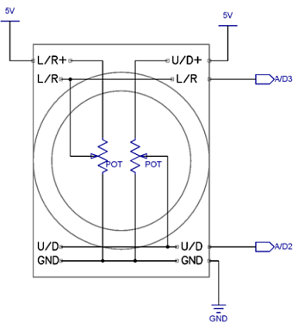
Figure 1
According to the data sheet, the Parallax joystick contains two 10 kΩ potentiometers, one for each axis. There are two outputs from joystick, which are two inputs of Arduino board. In my earliest prototype, I use three buttons for the moving base and four buttons for the swinging arm, which is shown in Figure 2. I totally used seven inputs, one input for each push button, to Arduino board.
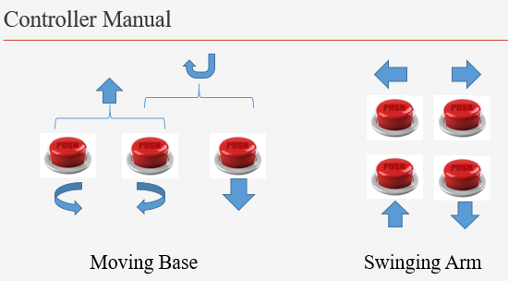
Figure 2
Now I replace them with joysticks. I only need two joysticks, one for the moving base and one for the swinging arm. I only have to use four inputs to Arduino board now. Accordingly, the codes have to be modified.
I am still working on the codes, especially the part how I transmit analog signal through Xbee (I used digital signal for all seven push buttons before in the early prototype).

How many hours I put into Senior Project this past week.
Two.

"Learn.parallax.com." Joystick. N.p., n.d. Web. 05 Mar. 2017. <http://learn.parallax.com/tutorials/language/propeller-c/propeller-c-simple-devices/joystick>.

